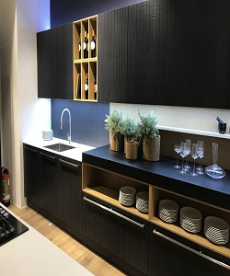

Universal kitchen cabinet

$189.89

Availability: In stock

Description

Modern white tall Kitchen Cabinets. Soft close hinges, drawer boxes and lifting mechanisms. Full assembly instructions are included in the box, certified for the highest quality.